The National Union of the Homeless and Food Not Bombs presents:
Memorial Day, 2020
Veterans, homelessness and hunger
in a time of pandemic.
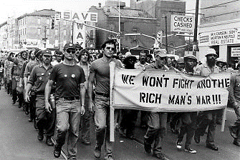
Forty years of feeding the people and organizing the homeless.
A global webinar of resistance with Homeless Union military veterans and Food Not Bombs volunteers.

Sunday, May 24, 2020: 12:30 pm PT/ 2:30 pm CT/3:30 pm ET

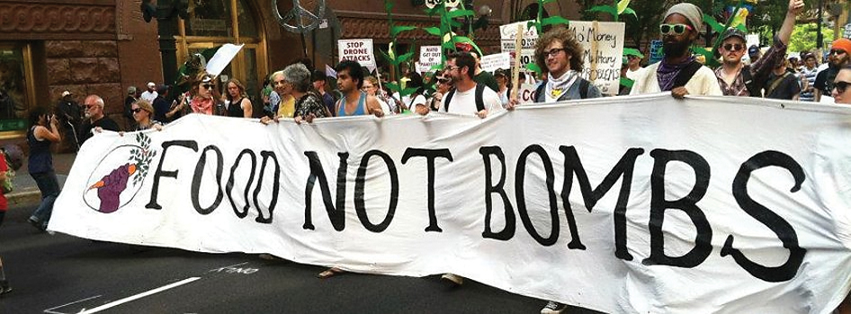
Bruce Parry, Treasurer, Coalition of Veterans Organizations * Keith McHenry, Founder, Food Not Bombs Jose Vasquez, Common Defense * Savina Martin, military veteran and founder, Boston Homeless Union Daniel Ochoa, Jr. Imperial Valley Veterans and Families Organizer * Alicia Kuhl, President, Santa Cruz Homeless Union * International Food Not Bombs Volunteers: Bulgaria, South Africa, Myanmar and Mexico
Please click the link below to join the webinar:
https://us02web.zoom.us/j/85484172758
Or iPhone one-tap :
US: +16465588656,,85484172758# or +13017158592,,85484172758#
Or Telephone:
Dial(for higher quality, dial a number based on your current location):
US: +1 646 558 8656 or +1 301 715 8592 or +1 312 626 6799 or +1 346 248 7799 or +1 669 900 9128 or +1 253 215 8782
Webinar ID: 854 8417 2758
International numbers available: https://us02web.zoom.us/u/kcjr1IkxHm

